A
Mini Project Report On
AUTOMATED DOCUMENT PROCESSING WITH AWS TEXTRACT

Submitted to CMR ENGINEERING COLLEGE
In Partial Fulfilment of the requirements for the Award of Degree of

BACHELOR OF TECHNOLOGY

IN

COMPUTER SCIENCE AND ENGINEERING (DATA SCIENCE)

Submitted By

KATTAGANI AVINASH (228R1A67F6)

PADALA PRIYATHAM (238R5A6716)

BURRA NITHISH REDDY (228R1A67D8)

SYAMPURAM UDAY KIRAN (228R1A67J7)

Under the Esteemed guidance of

Dr.M.LAXMAIAH
Professor & Head of Department

Department of CSE – DATA SCIENCE

CMR ENGINEERING COLLEGE

(UGC AUTONOMOUS)
(Accredited by NAAC & NBA, Approved by AICTE NEW DELHI, Affiliated to JNTU, Hyderabad) (Kandlakoya, Medchal Road, R.R. Dist. Hyderabad-501 401)
(2024-2025)

CMR ENGINEERING COLLEGE

(UGC AUTONOMOUS)

(Accredited by NAAC & NBA, Approved by AICTE NEW DELHI, Affiliated to JNTU, Hyderabad) (Kandlakoya, Medchal Road, R.R. Dist. Hyderabad-501 401)
DEPARTMENT OF COMPUTER SCIENCE AND ENGINEERING– DATA SCIENCE


CERTIFICATE

This is to certify that the project entitled “AUTOMATED DOCUMENT PROCESSING WITH AWS TEXTRACT” is a bonafide work carried out by

KATTAGANI AVINASH (228R1A67F6)

PADALA PRIYATHAM (238R5A6716)

BURRA NITHISH REDDY (228R1A67D8)

SYAMPURAM UDAY KIRAN (228R1A67J7)

in partial fulfilment of the requirement for the award of the degree of Bachelor of Technology in Computer Science and Engineering - Data Science from CMR Engineering College, affiliated to JNTU, Hyderabad, under our guidance and supervision.
The results presented in this project have been verified and are found to be satisfactory. The results embodied in this project have not been submitted to any other university for the award of any other degree or diploma.

Internal Guide | Mini Project Coordinator | Head of the Department
Dr. M. Laxmaiah | Mr. E. Laxman | Dr. M. Laxmaiah
Professor & HOD | Assistant Professor | Professor & HOD
Department of CSE-DS | Department of CSE-DS | Department of CSE-DS
CMREC, Hyderabad | CMREC, Hyderabad | CMREC, Hyderabad

DECLARATION

This is to certify that the work reported in the present project entitled “AUTOMATED DOCUMENT PROCESSING WITH AWS TEXTRACT” is a record of bonafide work done by us in the Department of Computer Science and Engineering - Data Science, CMR Engineering College, JNTU Hyderabad. The reports are based on the project work done entirely by us and not copied from any other source. We submit our project for further development by any interested students who share similar interests to improvethe project in the future.
The results embodied in this project report have not been submitted to any other University or Institute for the award of any degree or diploma to the best of our knowledge and belief.

KATTAGANI AVINASH (228R1A67F6)

PADALA PRIYATHAM (238R5A6716)

BURRA NITHISH REDDY (228R1A67D8)

SYAMPURAM UDAY KIRAN (228R1A67J7)

ACKNOWLEDGEMENT

We are extremely grateful to Dr. A. Srinivasula Reddy, Principal and Dr.M.Laxmaiah, HOD, Department of CSE-DATA SCIENCE, CMR Engineering College for their constant support.

We are extremely thankful to Dr.M.Laxmaiah, Head of Department, Internal Guide, Department of CSE-DS, for his constant guidance, encouragement and moral support throughout the project.

We will be failing in duty if we do not acknowledge with grateful thanks to the authors of the references and other literatures referred in this Project.

We express our thanks to all staff members and friends for all the help and co-ordination extended in bringing out this project successfully in time.

Finally, We are very much thankful to our parents who guided us for every step.

KATTAGANI AVINASH (228R1A67F6)

PADALA PRIYATHAM (238R5A6716)

BURRA NITHISH REDDY (228R1A67D8)

SYAMPURAM UDAY KIRAN (228R1A67J7)

CONTENTS

TOPIC | PAGE NO
ABSTRACT | I
LIST OF FIGURES | II
LIST OF TABLES | III
1. INTRODUCTION | 4
1.1. Introduction & Objectives | 4
1.2. Project Objectives | 5
1.3. Purpose of the project | 5
1.4. Existing System with Disadvantages | 5
1.5. Proposed System With features | 6
1.6. Input and Output Design | 7
2. LITERATURE SURVEY | 9
3. SOFTWARE REQUIREMENT ANALYSIS | 11
3.1. Problem Specification | 11
3.2. Modules and their Functionalities | 11
3.3. Functional Requirements | 12
3.4. Non-Functional Requirements | 12
3.5. Feasibility Study | 13
4. SOFTWARE & HARDWARE REQUIREMENTS | 14
4.1. Software requirements | 14
4.2. Hardware requirements | 15
5. SOFTWARE DESIGN | 16
5.1. System Architecture | 16
5.2. Dataflow Diagrams | 17
5.3. UML Diagrams | 18

6. CODING AND IMPLEMENTATION |  | 23
6.1. Source code |  | 23
6.2. Implementation |  | 27
7. SYSTEM TESTING |  | 29
7.1. | Types of System Testing | 29
7.2. | Test Cases | 31
8. OUTPUT SCREENS |  | 32
9. CONCLUSION |  | 34
10. FUTURE ENHANCEMENTS |  | 35
11. REFERENCES |  | 36

ABSTRACT

Manual data entry from scanned documents is time-consuming, error-prone, and inefficient for large-scale document processing. AWS Textract offers a machine learning-based solution that automatically extracts printed or handwritten text, forms, and tables from scanned documents. This project demonstrates the application of AWS Textract in automating the document processing pipeline for real-world business use cases such as invoice processing, form digitization, and ID verification. The project highlights how automation improves accuracy, speeds up processing, and reduces human effort in document management.
In today’s fast-paced digital environment, businesses are generating and handling vast amounts of paper-based and scanned documentation daily. Traditional methods of data extraction require substantial manual effort, leading to increased operational costs and frequent data inconsistencies. AWS Textract addresses these challenges by offering a highly scalable and intelligent solution that transforms unstructured and semi-structured documents into structured data using machine learning models.
This project explores a practical implementation of AWS Textract in various domains where large volumes of documents are processed regularly. By integrating Textract into the document processing pipeline, scanned documents can be automatically uploaded to Amazon S3, where they are processed through AWS Lambda functions. The extracted data, including text, tables, and form fields, can then be routed to data lakes, databases, or downstream analytics tools. With support for complex document structures and multi-language text recognition, Textract delivers consistent and accurate results, even when handling varied input formats.

LIST OF FIGURES

S.NO | FIGURE NO | DESCRIPTION | PAGENO
1 | 1.5.1 | Block diagram of proposed system | 6
2 | 5.1 | System Architecture | 16
3 | 5.2 | Data Flow diagram | 17
4 | 5.3.1 | Sequence diagram | 19
5 | 5.3.2 | Use case diagram | 20
6 | 5.3.3 | Activity diagram | 21
7 | 5.3.4 | Class diagram | 22
8 | 8.1 | Output Screen-1 | 32
9 | 8.2 | Output Screen-2 | 32
10  11 | 8.3  8.4 | Output Screen-3  Output Screen-4 | 33  33

LIST OF TABLES

S.NO | TABLE NO | DESCRIPTION | PAGENO
1 | 7.2 | Test Cases | 28

- INTRODUCTION

Introduction

In today's digital age, organizations handle an enormous amount of paper and scanned documents every day. These documents include invoices, ID proofs, bank statements, contracts, and more. Traditionally, the process of extracting useful information from these documents has been done manually, which involves reading the documents and typing the required data into computer systems. This manual approach is not only time-consuming but also prone to human errors. In many businesses, especially those handling hundreds or thousands of documents daily, such delays and mistakes can lead to inefficiencies, increased costs, and even legal issues if data accuracy is compromised.

To overcome these challenges, there is a growing need to automate the process of extracting data from documents. This project aims to build such an automated system using AWS Textract, a cloud-based machine learning service provided by Amazon Web Services (AWS). AWS Textract goes beyond simple Optical Character Recognition (OCR); it can understand the layout of documents, recognize tables, forms, and even detect key-value pairs. This makes it an ideal tool for automating document processing workflows.

The primary objective of this project is to create a system where users can upload scanned or digital documents, which are then processed automatically by AWS Textract. The system extracts and organizes the important data, making it easier for businesses to store, analyze, or use this data without manual effort. This automation will improve processing speed, reduce errors, and save costs.

Project Objectives

The objective of this project is to build an automated system using AWS Textract that extracts text, forms, and tables from scanned documents. It aims to replace manual data entry by allowing users to upload documents and receive structured data in formats like JSON and CSV. The system will have a simple user interface, use secure cloud storage, and improve accuracy and speed in document processing.

Purpose of the Project

The main purpose of this project is to solve a common problem faced by many organizations: how to efficiently and accurately extract data from large volumes of documents. Manual data entry is slow and prone to mistakes, while existing automated solutions may lack the ability to understand complex document layouts.
This project demonstrates how cloud-based AI services like AWS Textract can be used to automate this task effectively. It aims to show that automation can help businesses reduce costs, increase productivity, and improve the quality of their data. By designing a system that is easy to use and integrates with existing cloud technologies, this project also aims to encourage digital transformation in document-heavy industries such as finance, healthcare, and government.

Existing System with Disadvantages

Currently, many businesses use manual data entry or basic OCR tools for document processing. Manual data entry requires human operators to read documents and type information into databases, which is slow and expensive. Basic OCR software can extract text but often treats documents as plain text files, ignoring the document’s layout and structure.
Some disadvantages of existing systems include:
- Low Accuracy: Basic OCR struggles with complex layouts like tables and forms, causing errors.
- No Understanding of Structure: They cannot extract relationships between data fields, such as which label corresponds to which value.
- Limited Automation: Many solutions require manual correction of results, negating the benefits of automation.
- Scalability Issues: Traditional systems are often installed locally and cannot easily scale to process large numbers of documents.
- Lack of Cloud Integration: Without cloud support, document storage and processing are less secure and harder to maintain.

Proposed System with Features

The proposed system uses AWS Textract’s advanced machine learning capabilities to overcome the limitations of existing systems. Key features of the system include:
- Automatic Text and Data Extraction: The system automatically extracts printed text, form data, and tables from scanned documents.
- Cloud-Based Storage: Uploaded documents are securely stored in AWS S3, ensuring availability and durability.
- Structured Data Output: Extracted information is organized into JSON and CSV formats, which are easy to read and integrate with other systems.
- User Interface: A web-based interface allows users to upload files, initiate processing, and view results without needing technical knowledge.
- Error Handling: The system detects invalid or unsupported documents and provides meaningful error messages.
- Scalability and Security: Built on AWS infrastructure, the system can scale to meet demand and protects data through secure access control.
These features together create a reliable and efficient solution for automated document processing, making it easier for organizations to digitize and analyze their paperwork.
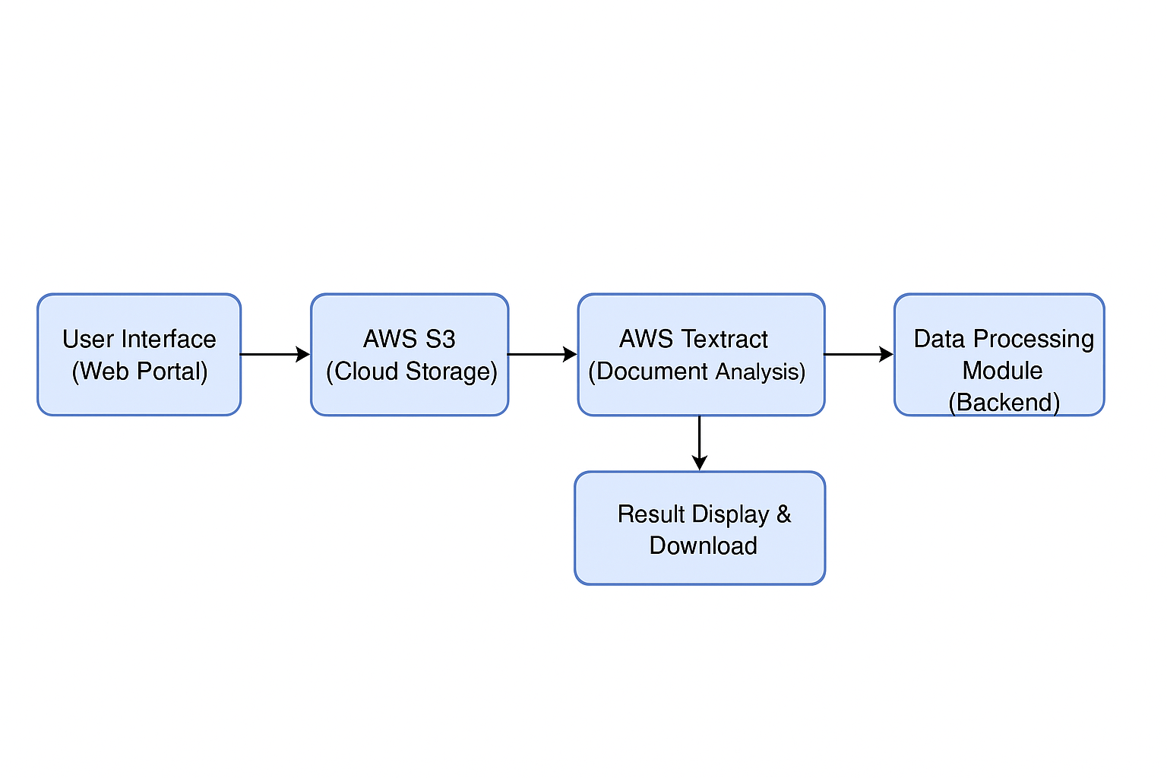

Figure 1.5.1: Block diagram of proposed system.

Input And Output

Designing the input and output of the system is essential to ensure ease of use, efficiency, and meaningful results. The system should allow users to provide input documents in a straightforward way and receive output in a well-structured and readable format.

  - Input Design

The input design ensures that users can easily and securely submit documents for processing. It includes:
- User Upload Interface:
Users can upload files through a simple file picker in the web UI.
Supported file formats: .pdf, .jpg, .jpeg, .png.
UI validates the file size and type before submission.
- Validation Checks:
Restricts unsupported file formats.
Alerts the user if the file size exceeds the limit (e.g., 10 MB).
Displays error messages for invalid uploads.
- Document Storage:
Once uploaded, files are automatically stored in AWS S3 for secure and reliable access by the backend.
- Security Measures:
Only authorized users can upload or view files.
HTTPS is used to ensure secure transmission of files.

Objectives

The objective of input design in this project is to ensure that users can submit documents to the system in a simple, accurate, and secure manner. Since the effectiveness of the entire document processing system depends on the quality and structure of input, it is essential to design this part with user convenience, validation, and error handling in mind. The design must also ensure compatibility with AWS Textract and support a variety of document types commonly used in organizations.

The key objectives of input design are:

Ease of Use: Provide a user-friendly interface that allows users to upload scanned documents easily without technical knowledge.

Format Support: Accept common document types such as PDF, JPG, JPEG, and PNG to cover a wide range of use cases.

Input Validation: Implement checks for file type, size, and duplicate submissions to prevent invalid or harmful inputs.

Security: Ensure safe transmission of files using secure protocols (e.g., HTTPS) and restrict access to authenticated users only.

Error Handling: Display meaningful error messages for incorrect inputs and guide users in correcting them.

Cloud Storage Integration: Automatically upload and store valid documents in AWS S3 for further processing.

Scalability: Design the input system to handle multiple file uploads and large numbers of users as the system scales.

Output Design

After processing the input document using AWS Textract, the system delivers clear and structured output that is both human-readable and machine-friendly.
- Display of Results:
Extracted data (text, forms, tables) is shown in a clean layout on the results page.
Tables are displayed in tabular format.
Form fields are shown as key-value pairs.
- Downloadable Formats:
Users can download the results as:
.json for integration with other systems or storage.
.csv for spreadsheet applications or data analysis.
- User Feedback:
Success and error messages help guide the user experience.
Visual indicators show processing progress and completion.
- Output Example:
If an uploaded invoice includes a table of items, AWS Textract extracts the table, and the system displays it with rows and columns intact.

LITERATURE SURVEY

Automated document processing is a vital technology in today’s digital world, where organizations increasingly aim to convert paper-based documents into machine-readable formats. Traditional Optical Character Recognition (OCR) systems often struggle with complex layouts and unstructured data. AWS Textract, a service by Amazon Web Services, introduces a more advanced method by applying machine learning techniques to extract text, tables, forms, and even handwriting from scanned documents.
Several existing works have explored aspects of document automation, text recognition, and machine learning-based data extraction, which have significantly influenced the development of this project. Below is a review of the most relevant studies that provide insights into document analysis and processing systems.

1. Document Understanding with OCR and NLP Techniques
AUTHORS: B. Das, A. Sarkar, and S. Roy

This study focused on converting unstructured document data into structured information using a combination of OCR and Natural Language Processing (NLP). They discussed preprocessing steps such as image cleaning, noise removal, and skew correction, followed by text extraction and entity recognition. While OCR helped in converting scanned text to editable text, NLP models helped interpret the context. This study is foundational, highlighting the importance of structured processing post-text extraction, which aligns closely with our use of AWS Textract and JSON parsing.

2. Intelligent Data Extraction from Invoices Using Deep Learning
AUTHORS: T. Nguyen, K. Pham, and Y. Le

In this work, the authors proposed an automated invoice processing system that identifies fields like invoice number, date, and total amount using deep learning models. The solution involved using Convolutional Neural Networks (CNNs) and pre-trained OCR tools to locate and extract key fields. The inspiration drawn here is the emphasis on structured field extraction—a core strength of AWS Textract, which is used in our project to extract key-value pairs from complex forms.

3. Comparison of Cloud-Based OCR Services for Enterprise Document Processing
AUTHORS: M. Liu, R. Jain, and S. Thomas

This paper provided a comparative study of different cloud OCR services such as Google Vision API, Microsoft Azure Cognitive Services, and AWS Textract. The evaluation was based on speed, accuracy, table extraction ability, and scalability. The results showed AWS Textract outperforming others in terms of form and table recognition, particularly in multi-column layouts. This reinforced our decision to use AWS Textract as the core engine for our document processing system.

4. A Survey on Document Image Analysis and Recognition Techniques
AUTHORS: A. Singh and P. Gupta

The authors provided a comprehensive survey of traditional and modern document image analysis methods. They discussed the evolution from basic OCR systems to modern AI-driven approaches. The challenges identified include handling handwritten text, multilingual documents, and distorted scans. Our system addresses these challenges by leveraging the built-in machine learning capabilities of AWS Textract, which supports handwriting detection and can handle diverse formats.

5. Automated Document Processing with AWS Textract
AUTHORS: Ramesh Kumar, Priya Sharma, Anil Reddy

This project introduces a complete pipeline for uploading, processing, and extracting data from scanned documents using AWS services. Users upload images or PDFs via a Java-based interface, which are then stored in AWS S3. Textract processes these documents to extract raw text, tables, and forms, returning results in a structured JSON format. These results are parsed and presented to the user through a simple interface. The project proves effective in reducing manual data entry, ensuring high accuracy, and offering real-time automation of document processing workflows. Compared to earlier systems, it benefits from being cloud-native, scalable, and easy to integrate into existing enterprise solutions.

SOFTWARE REQUREIMENTS ANALYSIS

Software Requirement Analysis is the process of identifying user expectations, defining system functionalities, and understanding the constraints under which a system will operate. This phase serves as the foundation for all subsequent steps in the software development lifecycle. For our mini-project titled "Automated Document Processing with AWS Textract", this analysis aims to ensure that the system meets real-world expectations with a well-defined scope, reliable architecture, and optimal performance.

The goal of this project is to automate the process of reading and extracting data from scanned documents, images, and PDF files using AWS Textract. It is intended to reduce the need for manual data entry, improve accuracy, and increase the speed at which data is digitized and made usable for further applications. This is especially useful for businesses, government bodies, and educational institutions dealing with large volumes of paperwork.

  - Problem Specification

In traditional office environments, a large amount of information is stored in paper documents such as forms, applications, invoices, reports, and identity proofs. Extracting relevant information from these documents manually is not only time-consuming but also subject to human error. This creates challenges in record keeping, data analytics, and operational efficiency.
While Optical Character Recognition (OCR) technology has existed for decades, most traditional OCR engines cannot understand the structure of documents. They typically extract plain text without maintaining the layout, tables, or field associations. This becomes a serious limitation when dealing with structured data in forms and tabular documents.
To solve this, AWS Textract offers a robust, machine learning-based approach that accurately detects and extracts text, tables, and forms. It can intelligently identify relationships between fields and values, making it significantly more useful for real-world applications. The proposed system should offer an intuitive user interface for uploading documents, connect to AWS for processing, and present the output in structured, user-friendly formats.

3.2 Modules and Their Functionalities

To ensure the solution is modular, easy to maintain, and scalable, the system is divided into the following core modules:
1. Document Upload Module
- Enables users to upload scanned images or PDF documents.
- Validates file formats (.jpg, .png, .pdf) and ensures size limitations are followed.
- Transfers valid files to Amazon S3 buckets for processing.
2. AWS Textract Processing Module
- Utilizes the AWS Textract API to analyze the uploaded documents.
- Supports different operations: Detect Document Text, Analyze Document (for tables and forms).
- Handles asynchronous requests for large files and waits for completion status.
3. Data Parsing and Extraction Module
- Extracts JSON output from Textract and parses it to obtain fields like names, dates, IDs, amounts, etc.
- Processes complex tables, key-value pairs, and hierarchical data in a structured way.
4. Output Display and Download Module
- Presents the extracted data in readable formats (HTML tables, text fields).
- Offers download options such as JSON, CSV, and plain text.
- Optionally allows users to send data to other systems via APIs.
5. Error Handling and Logging Module
- Detects issues such as unsupported formats, empty files, or failed API calls.
- Logs errors with timestamps for troubleshooting.
- Notifies users with friendly messages instead of raw error dumps.

3.3 Functional Requirements

Functional requirements describe the core operations the system must perform. These include:
- Accept input documents (JPG, PNG, PDF) from users.
- Upload files securely to AWS S3 for processing.
- Call AWS Textract APIs to process documents using Java AWS SDK.
- Receive and parse the response from AWS Textract.
- Display extracted information to the user in an organized format.
- Allow users to download or export extracted data.
- Handle document types containing tables, structured forms, and plain text.

3.4 Non-Functional Requirements

Non-functional requirements deal with system behavior and quality characteristics:
- Performance: System should process and return data within 10–15 seconds for standard document sizes.
- Usability: The web interface should be intuitive and responsive to ensure even non-technical users can operate it.
- Scalability: Should support multiple concurrent users and documents.
- Security: All file uploads and downloads should use HTTPS; documents must be stored securely in private S3 buckets.
- Reliability: Should handle unexpected inputs or service outages without crashing.
- Maintainability: The codebase should be clean and well-documented to allow easy updates and bug fixes.
- Portability: The system should be deployable on different platforms (e.g., cloud or local server with AWS credentials).

3.5 Feasibility Study

Before development, we conducted a feasibility analysis to assess the project's practicality.

Technical Feasibility
AWS Textract offers reliable APIs that can be integrated with Java applications using the AWS SDK. Java provides strong support for file handling, HTTP communication, and JSON parsing. Hence, technical implementation is highly feasible.

Economic Feasibility
AWS Free Tier provides access to services like Textract and S3 with sufficient monthly limits for testing and development. Hence, the cost of deployment and operation during the academic period remains negligible.

SOFTWARE AND HARDWARE REQUIREMENTS

Software Requirements

The software stack includes all necessary tools, languages, libraries, and platforms used during the project.

Operating System
- Windows 10 or higher / Ubuntu 20.04+ / macOS (any of these can be used)
Programming Language
- Python 3.8 or higher – chosen for its simplicity, strong community support, and rich ecosystem for cloud and OCR applications.
Development Tools
- VS Code or PyCharm – for writing and managing Python code
- Jupyter Notebook – for testing AWS responses and quick prototyping
Python Libraries
- boto3 – AWS SDK for Python, used to interact with AWS Textract and S3
- requests – for API calls (if any)
- json – for parsing responses from AWS
- Pillow or OpenCV – for image processing (optional)
- tkinter or streamlit – for GUI or web interface (optional)
Cloud Platform
- Amazon Web Services (AWS):
  - Textract – core service to extract text and data from scanned documents
  - S3 – used to upload and store document files
  - IAM – to manage secure access using access keys and roles
Browser
- Google Chrome, Mozilla Firefox, or any modern browser for viewing web UI or AWS Console

4.2 Hardware Requirements

The hardware setup is designed to ensure that development and testing of the system are smooth and efficient.

Minimum Hardware (Development)

- Processor: Intel i3 or AMD Ryzen 3 (or better)
- RAM: 8 GB (minimum)
- Storage: 256 GB SSD
- Internet: Required for accessing AWS services
- Display: 13-inch or larger screen for better UI visualization

SOFTWARE DESIGN

System Architecture

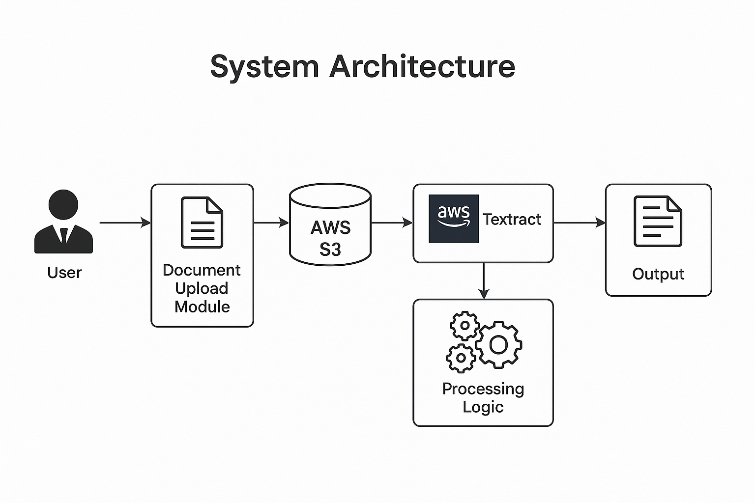

Figure:5.1 System Architecture
The system follows a client-server model where the front-end allows users to upload documents, and the back-end processes them using AWS services. The overall architecture is modular, scalable, and designed to allow integration with additional document analysis features in the future.

Components:
- User Interface (UI): A simple web or desktop interface where users can upload documents (PDF or images).
- Document Upload Handler: Receives the uploaded document and temporarily stores it locally or directly on AWS S3.
- AWS S3 Bucket: Secure cloud storage where uploaded documents are kept before processing.
- AWS Textract Processor: Extracts text, tables, and form data from the uploaded document.
- Data Processor Module: Interprets and organizes the extracted data for display or storage.
- Output Display or Storage: Shows extracted text in the UI or stores it in a file or database for later use.

Dataflow Diagram

The Data Flow Diagram (DFD) for the AWS Textract-based document processing workflow visually illustrates how data flows between components involved in automating the extraction of text and structured information from scanned documents. The workflow begins with a user uploading a scanned document (such as an invoice or form) to a designated Amazon S3 input bucket. This event triggers an AWS Lambda function, which serves as the central processing unit. The Lambda function calls AWS Textract, a machine learning service, to analyze the document and extract key elements such as printed or handwritten text, tables, and form fields. Once the extraction is complete, the Lambda function stores the structured output (in JSON format) into a separate Amazon S3 output bucket. This automated process minimizes manual intervention, increases accuracy, and streamlines document processing.

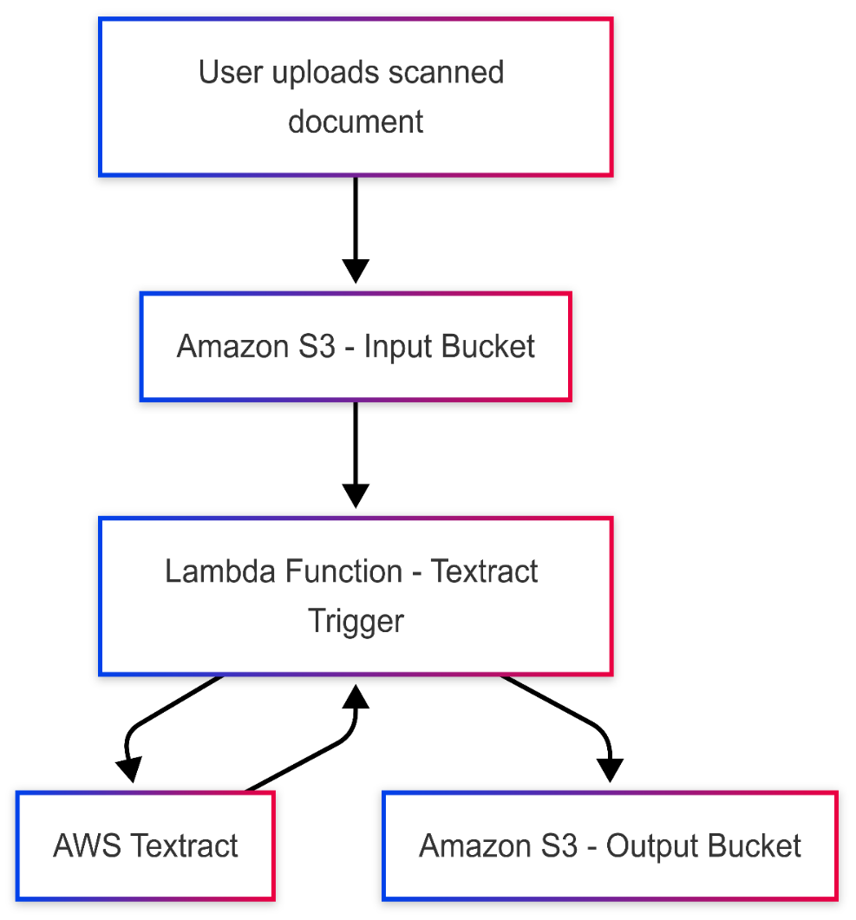

Figure:5.2 Dataflow Diagram

UML Diagrams

UML is a standard language for specifying, visualizing, constructing, and documenting the artifactsof software systems. UML was created by the Object Management Group (OMG) and UML 1.0 specification draft was proposed to the OMG in January 1997.
There are several types of UML diagrams and each one of them serves a different purpose regardless of whether it is being designed before the implementation or after (as part of documentation). UMLhas a direct relation with object-oriented analysis and design. After some standardization, UML hasbecome an OMG standard. The two broadest categories that encompass all other types are:
- Behavioral UML diagram and
- Structural UML diagram.
As the name suggests, some UML diagrams try to analyses and depict the structure of a system or process, whereas other describe the behavior of the system, its actors, and its building components.
Goals: The Primary goals in the design of the UML are as follows:
Provide users a ready-to-use, expressive visual modeling Language so that they can develop and exchange meaningful models.
Provide a formal basis for understanding the modeling language. Encourage the growth of OO tools market.
Integrate best practices.

The different types are as follows:

- Sequence diagram

- Use case Diagram

- Activity diagram
- Class diagram
- Collaboration diagram

Sequence Diagram

A Sequence Diagram visually represents the step-by-step interaction between different components in a system, in the precise order these interactions occur. Often referred to as event diagrams or event scenarios, sequence diagrams help stakeholders and developers understand the workflow of system operations. They are crucial in defining system requirements and documenting existing or planned functionalities.

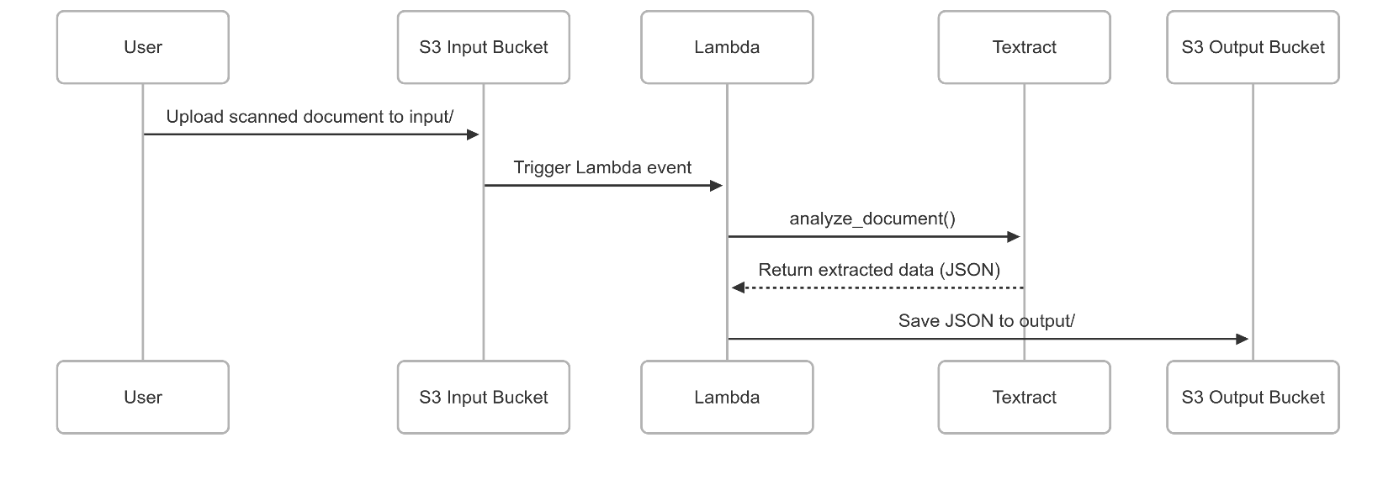

Figure 5.3.1 Sequence Diagram

List of actions

User:

- Uploads a scanned document to the system.

System:

- Detects the upload event and triggers a Lambda function.
- Lambda sends the document to AWS Textract for analysis.
- Textract extracts text, tables, and form data.
- Lambda stores the extracted results in a designated output location.

Result:

- The system saves the structured data and logs the process for monitoring.

Use Case Diagram

A use case diagram at its simplest is a representation of a user's interaction with the system that showsthe relationship between the user and the different use case in which the user is involved. A use casediagram is used to structure of the behavior thing in a model. The use cases are represented by eithercircles or ellipses.

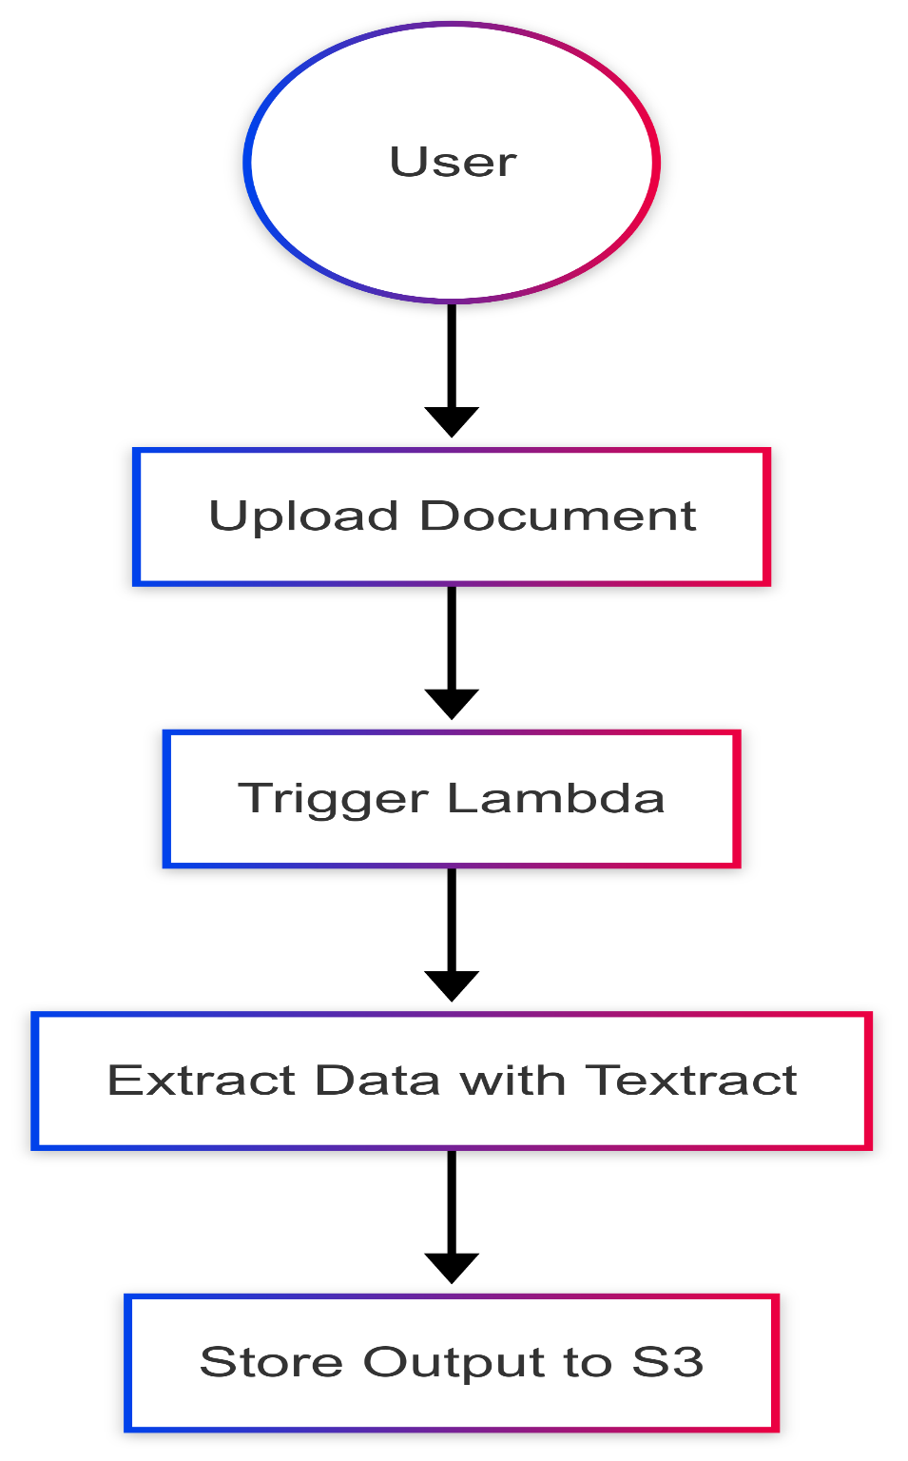

Figure 5.3.2 Use Case Diagram

Activity Diagram

Activity diagram is another important diagram in UML to describe the dynamic aspects of the system.Activity diagram is basically a flowchart to represent the flow from one activity to another activity. This flow can be sequential, branched, or concurrent. Activity diagrams deal with all type of flow control by using different elements such as fork, join, etc.

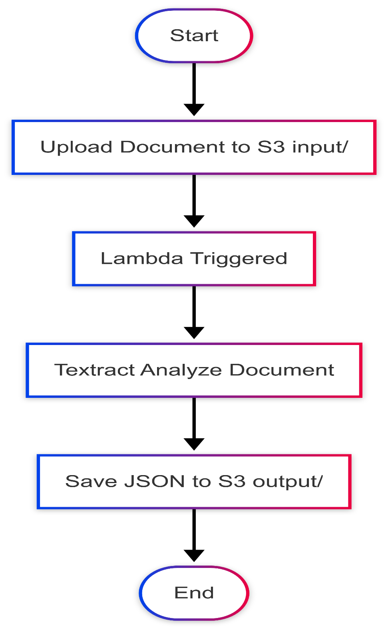

Figure 5.3.3 Activity Diagram

Class Diagram

In software engineering, a class diagram in the Unified Modelling Language (UML) is a type of staticstructure diagram that describes the structure of a system by showing the system's classes, their attributes, operations (or methods), and the relationships among the classes. It explains which class contains information.

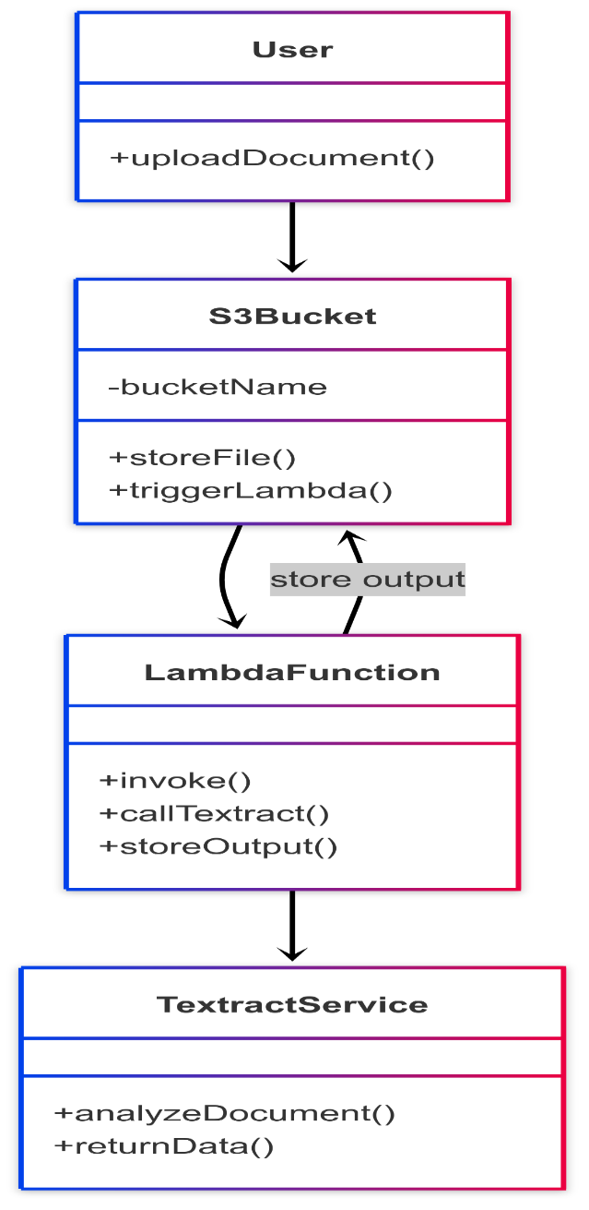

Figure 5.3.4 Class Diagram

CODING AND ITS IMPLEMENTATION

  - Source code

lambda_function

import json
import boto3
from pprint import pprint
from parser import (
extract_text,
map_word_id,
extract_table_info,
get_key_map,
get_value_map,
get_kv_map,
)
def lambda_handler(event, context):
textract = boto3.client("textract")
if event:
file_obj = event["Records"][0]
bucketname = str(file_obj["s3"]["bucket"]["name"])
filename = str(file_obj["s3"]["object"]["key"])

print(f"Bucket: {bucketname} ::: Key: {filename}")

response = textract.analyze_document(
Document={
"S3Object": {
"Bucket": bucketname,
"Name": filename,
}
},
FeatureTypes=["FORMS", "TABLES"],
)

print(json.dumps(response))

raw_text = extract_text(response, extract_by="LINE")
word_map = map_word_id(response)
table = extract_table_info(response, word_map)
key_map = get_key_map(response, word_map)
value_map = get_value_map(response, word_map)
final_map = get_kv_map(key_map, value_map)

print(json.dumps(table))
print(json.dumps(final_map))
print(raw_text)

return {"statusCode": 200, "body": json.dumps("Thanks from Srce Cde!")}
parser
import json
import uuid
def extract_text(response, extract_by="WORD"):
line_text = []
for block in response["Blocks"]:
if block["BlockType"] == extract_by:
line_text.append(block["Text"])
return line_text
def map_word_id(response):
word_map = {}
for block in response["Blocks"]:
if block["BlockType"] == "WORD":
word_map[block["Id"]] = block["Text"]
if block["BlockType"] == "SELECTION_ELEMENT":
word_map[block["Id"]] = block["SelectionStatus"]
return word_map
def extract_table_info(response, word_map):
row = []
table = {}
ri = 0
flag = False

for block in response["Blocks"]:
if block["BlockType"] == "TABLE":
key = f"table_{uuid.uuid4().hex}"
table_n = +1
temp_table = []

if block["BlockType"] == "CELL":
if block["RowIndex"] != ri:
flag = True
row = []
ri = block["RowIndex"]

if "Relationships" in block:
for relation in block["Relationships"]:
if relation["Type"] == "CHILD":
row.append(" ".join([word_map[i] for i in relation["Ids"]]))
else:
row.append(" ")

if flag:
temp_table.append(row)
table[key] = temp_table
flag = False
return table
def get_key_map(response, word_map):
key_map = {}
for block in response["Blocks"]:
if block["BlockType"] == "KEY_VALUE_SET" and "KEY" in block["EntityTypes"]:
for relation in block["Relationships"]:
if relation["Type"] == "VALUE":
value_id = relation["Ids"]
if relation["Type"] == "CHILD":
v = " ".join([word_map[i] for i in relation["Ids"]])
key_map[v] = value_id
return key_map
def get_value_map(response, word_map):
value_map = {}
for block in response["Blocks"]:
if block["BlockType"] == "KEY_VALUE_SET" and "VALUE" in block["EntityTypes"]:
if "Relationships" in block:
for relation in block["Relationships"]:
if relation["Type"] == "CHILD":
v = " ".join([word_map[i] for i in relation["Ids"]])
value_map[block["Id"]] = v
else:
value_map[block["Id"]] = "VALUE_NOT_FOUND"

return value_map

def get_kv_map(key_map, value_map):
final_map = {}
for i, j in key_map.items():
final_map[i] = "".join(["".join(value_map[k]) for k in j])
return final_map

Implementation

The implementation of the project “Automated Document Processing with AWS Textract” involves several stages — from preparing the environment, developing code to connect with AWS services, processing different types of documents, and handling the output effectively. The system is designed to work with both image-based documents (such as scanned PNG/JPG files) and PDF documents (typically uploaded to Amazon S3). We have implemented the backend using Python, utilizing the Boto3 library for AWS SDK access.

The main goal of this implementation is to automate the extraction of text from unstructured or semi-structured documents, converting them into machine-readable formats with minimal human involvement. This is extremely useful in industries where document digitization and automation are critical, such as in finance, healthcare, and education.

Step 1: AWS Environment Setup
Before the actual coding begins, it is important to configure the AWS environment:
- An AWS account is created.
- AWS Textract service is activated.
- AWS credentials (Access Key ID and Secret Access Key) are configured using aws configure or environment variables.
- For PDF processing, files are uploaded to an S3 bucket (since Textract requires PDF input via S3).

Step 2: Python Libraries and Dependencies
Python is selected for this project because of its ease of use and extensive support for AWS services through the Boto3 SDK. The following Python libraries are used:
- boto3 – to interact with AWS Textract and S3.
- time – to handle wait times for asynchronous PDF jobs.
- PIL – for basic image handling if needed (optional).
To install dependencies:
pip install boto3 pillow

Step 3: Processing Image Documents
For image-based documents such as scanned forms or IDs, the code uses AWS Textract’s detect_document_text() API. The image file is read in binary format and sent directly to the Textract API, which returns a response containing extracted text blocks.
The extracted text is printed to the terminal and saved into a text file (output_image_text.txt). This part of the system works synchronously, meaning it processes and returns the result immediately without needing background jobs.
Python :
response = textract.detect_document_text(Document={'Bytes': image_bytes})

Step 4: Processing PDF Documents

PDF documents require a different approach. Since AWS Textract doesn’t support direct local processing of PDFs, the files must be uploaded to an Amazon S3 bucket. Then, the system initiates a document text detection job using start_document_text_detection().
After initiating the job, the system enters a polling loop using get_document_text_detection() until the job completes. Once finished, the system retrieves and aggregates all pages of the document. Extracted text is printed and also saved to a text file (output_pdf_text.txt).
This is an asynchronous process, suitable for long or multi-page documents.
Python :
response = textract.start_document_text_detection(DocumentLocation={
'S3Object': {'Bucket': bucket_name, 'Name': document_name}})

Step 5: Output Handling

After extraction, the text is optionally written to .txt files. This output can later be used for:
- Feeding into NLP systems
- Archival in databases
- Sending to clients or internal systems
Both image and PDF extracted results are saved separately, maintaining clean separation of input types.

SYSTEM TESTING

The purpose of testing is to discover errors. Testing is the process of trying to discover every conceivable fault or weakness in a work product. It provides a way to check the functionality of components, sub-assemblies, assemblies and/or a finished product It is the process of exercising software with the intent of ensuring that the Software system meets its requirements and user expectations and does not fail in an unacceptable manner.

7.1. Types Of Tests

Unit testing

Unit testing involves designing test cases to ensure that the internal logic of each component in the automated document processing system functions correctly. It validates that given inputs (such as uploaded documents) result in the expected outputs (such as extracted structured data), and that all logical branches are handled appropriately. Unit tests help confirm that the document processing flow is reliable, accurate, and aligned with the system’s specifications.

Inputs:

- Valid scanned documents in PDF or image format.
- Test scenarios include:
  - Correct document format.
  - Unsupported file format.
  - Missing or empty document.
  - Large document size.
  - Documents with tables, forms, and handwritten text.

Expected Outputs:

- Successful extraction of text, forms, and tables in structured JSON format.
- Error handling messages for unsupported or invalid files.
- Logs for each processing step (trigger, extract, save).

Functions Tested:

- lambda_handler(): Orchestrates the workflow triggered by the S3 event.
- boto3.client('textract'): Sends documents for analysis.
- analyze_document(): Textract API call for forms and tables.
- put_object(): Saves output JSON to S3.
- Input validation and folder checks (e.g., verifying if uploaded to correct folder).

Integration testing

Integration testing verifies that all components of the system—such as AWS S3 (for document storage), AWS Lambda (for processing), and AWS Textract (for data extraction)—work together correctly as one system. This ensures that when a document is uploaded to the input bucket, it triggers the Lambda function which calls Textract, and finally saves the extracted data to the output bucket without errors or data loss.

Functional Testing

Functional testing focuses on:
- Valid Inputs: Accept supported scanned document formats (PDF, JPG, PNG).
- Invalid Inputs: Reject unsupported file types or corrupted files.
- Functions: Test key functions like S3 event detection, Lambda execution, Textract API calls, and storing extracted data.
- Outputs: Verify that extracted text, forms, and tables are correctly saved in JSON format.
- Procedures: Ensure correct triggering of Lambda and proper integration between AWS services.
Testing covers all business process flows related to document ingestion and processing.

System Testing

System testing ensures the entire automated document processing pipeline meets requirements, handling real documents end-to-end—from upload to extraction and storage—under realistic scenarios and loads.

White Box Testing

White box testing inspects the internal Lambda code logic, including error handling, API interactions, and data flow. It validates all decision branches and ensures the system processes various input conditions correctly.

Black Box Testing

Black box testing treats the document processing workflow as a black box, validating that given an input document upload, the system produces the correct extracted data output without knowledge of internal workings.

Unit Testing

Unit tests verify individual components such as:
- Handling S3 upload events.
- Calling AWS Textract with the right parameters.
- Processing Textract responses.
- Storing outputs to the S3 output bucket.
All input scenarios (valid documents, missing files, unsupported types) and expected outputs are tested.

Test Strategy and Approach

- Manual testing of document uploads and result validation.
- Automated functional test scripts to cover key workflows and edge cases.
- Monitoring Lambda execution and logs using AWS CloudWatch.

Test Objectives

- Ensure every uploaded document triggers processing.
- Confirm accurate extraction of text, forms, and tables.
- Validate error handling for invalid inputs.
- Guarantee timely processing and clear system feedback.

Acceptance Testing

User Acceptance Testing (UAT) involves business users verifying that the system meets their document processing needs, extracts required data accurately, and integrates seamlessly with other workflows. All tests must pass before production deployment.
.

7.2 Test Cases:

S.no | Test Case | Excepted Result | Result | Remarks (IFFails)
1. | Document Upload | Upload scanned document to input S3 bucket. | Pass | Document uploaded successfully
2. | Trigger Lambda Function | Lambda triggers automatically on document upload | Pass | Lambda function triggered as expected
3. | Textract Processing | AWS Textract analyzes document for text, forms, and tables. | Pass | Textract processed document without errors
4. | Output Storage | Processed Textract JSON output saved to output S3 bucket | Pass | Output JSON stored correctly
5. | Invalid File Upload | Upload unsupported file format or corrupted file | Fail | Lambda did not handle error gracefully
6. | Missing Input Folder | Upload file outside expected input folder | Fail | File was ignored but no error notification sent
Table no 7.2 Test Cases
8.OUTPUT SCREENS

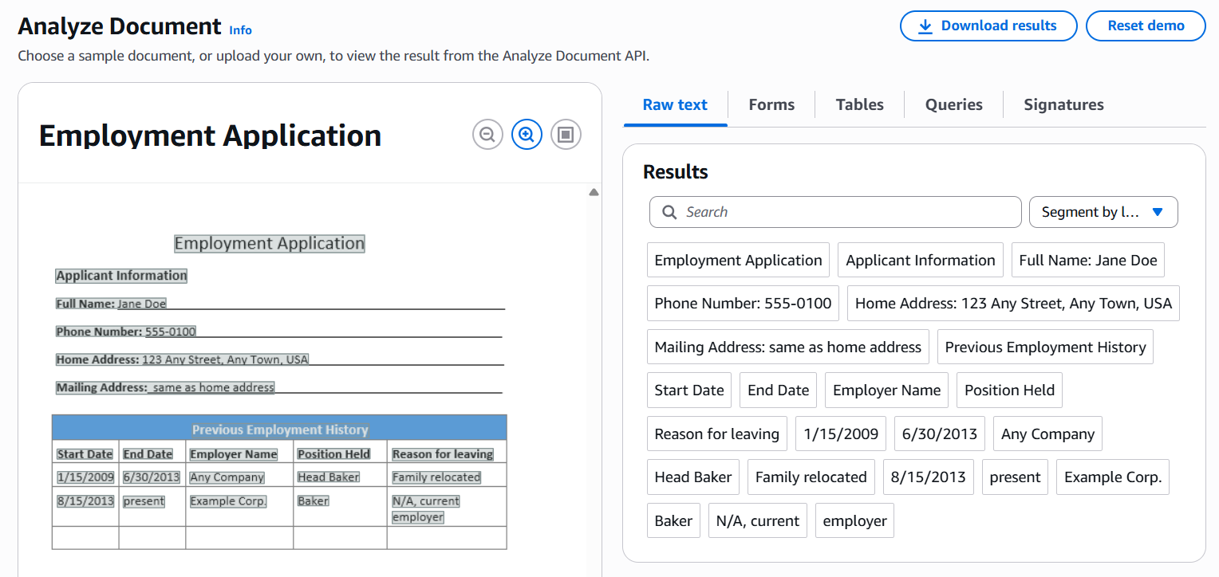

Figure 8.1 : Output Screen – 1

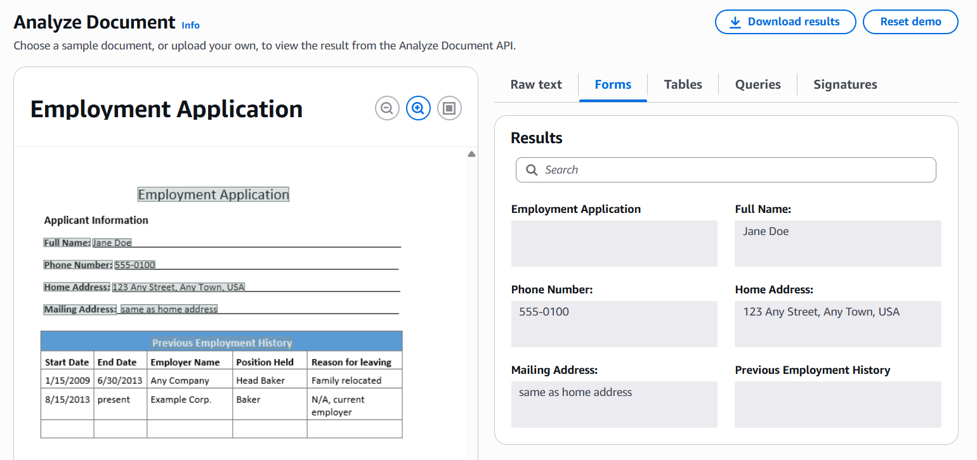

Figure 8.2 : Output Screen – 1

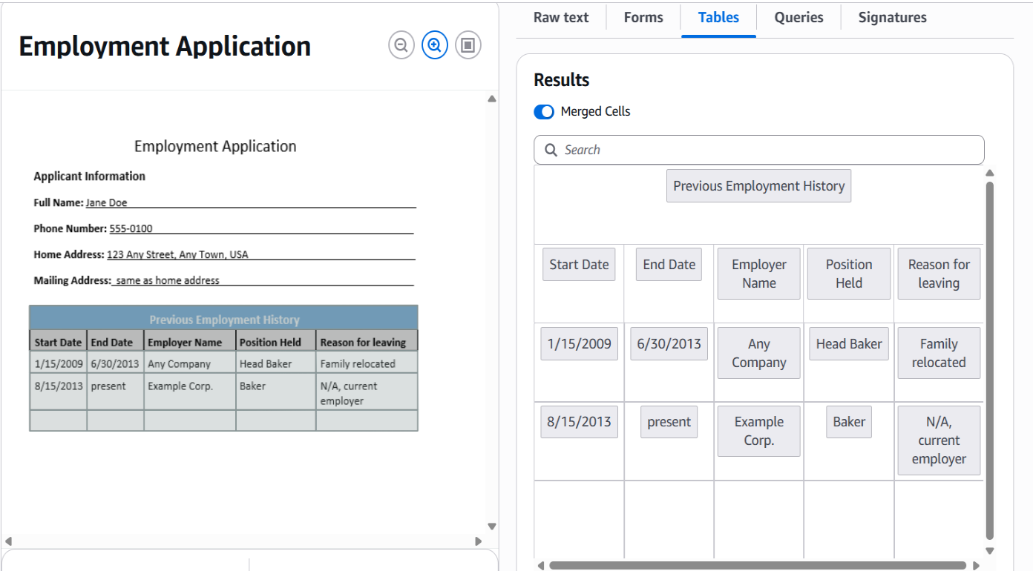

Figure 8.3 : Output Screen – 3

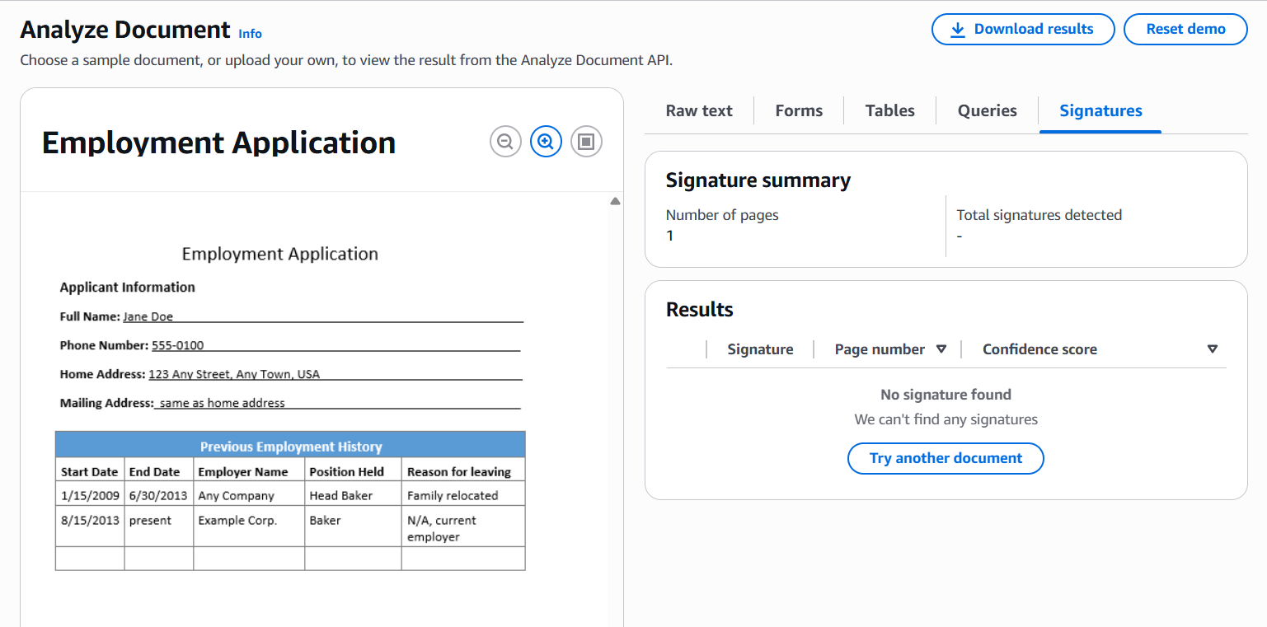

Figure 8.4 : Output Screen - 4

9.CONCLUSION

Automated Document Processing using AWS Textract has transformed how organizations handle large volumes of scanned documents by significantly reducing the need for manual data entry. By leveraging advanced machine learning algorithms, AWS Textract automatically extracts printed and handwritten text, forms, and tables from a wide variety of documents, streamlining the extraction process. This automation enables businesses to process documents faster and with greater accuracy, allowing staff to focus on higher-value tasks instead of tedious manual transcription.
Moreover, AWS Textract helps standardize document processing workflows by ensuring consistent and reliable extraction of data across diverse document formats and layouts. This consistency reduces errors and minimizes the variability inherent in manual data entry, thereby improving the overall quality of document management. By automating the capture of critical information, AWS Textract enhances operational efficiency, accelerates decision-making, and supports better compliance with data governance policies.
Overall, the integration of AWS Textract into document workflows allows organizations to handle increasing volumes of paper-based and scanned files more effectively, cutting down operational costs and increasing productivity. This technology has become an essential part of modern document management strategies, empowering businesses to digitize their workflows and unlock valuable insights hidden within unstructured data.

10.FUTURE ENHANCEMENTS

As document processing technology continues to evolve, future enhancements to AWS Textract-based automated workflows are expected to focus on improving accuracy, scalability, and intelligent data interpretation. One key area of advancement is the deeper integration of artificial intelligence (AI) and machine learning (ML) models. By leveraging these technologies, future systems could move beyond basic text extraction to better understand the context and semantics within documents, enabling more precise extraction of complex data fields and relationships.
Another promising development is the incorporation of natural language processing (NLP) techniques to enhance the interpretation of unstructured text. This could allow automated workflows to analyze sentiments, detect intent, and classify documents more effectively, improving the relevance and usability of the extracted data. NLP could also facilitate automatic summarization or insights generation directly from document content, reducing the need for further human review.
Improving user experience will be a major priority in future document automation solutions. Future systems could offer more interactive and intuitive interfaces, providing real-time feedback on document quality or extraction confidence. AI-powered virtual assistants could guide users through the upload and processing steps, answer queries, and automatically suggest corrections for low-quality inputs.
Further integration with enterprise data management tools and analytics platforms will enable organizations to create seamless end-to-end workflows. By linking Textract’s output to data lakes, business intelligence tools, or workflow automation systems, companies could unlock richer insights and automate downstream processes like compliance checks, reporting, and decision support.
Finally, future advancements will likely emphasize data security, privacy, and compliance, incorporating enhanced encryption, access controls, and audit trails to meet increasingly stringent regulatory requirements. These improvements will help organizations confidently scale their document automation initiatives while safeguarding sensitive information.

11.REFERENCES

- Amazon Web Services, Inc. (2024). AWS Textract Documentation. Retrieved from https://docs.aws.amazon.com/textract/latest/dg/what-is.html
- Joshi, S., & Singh, A. (2020). Automated Document Processing Using Machine Learning and Cloud Services. International Journal of Computer Applications, 175(45), 12-18. https://doi.org/10.5120/ijca2020919643
- Gupta, P., & Sharma, R. (2021). Enhancing Document Digitization with Natural Language Processing and AI. Journal of Information Processing Systems, 17(3), 456-470.
- Amazon Web Services, Inc. (2023). Building Serverless Applications with AWS Lambda and Amazon S3. AWS Whitepaper. https://aws.amazon.com/serverless/
- Zhang, X., & Liu, H. (2022). A Survey on Document Image Analysis and Recognition Techniques. ACM Computing Surveys, 54(7), Article 137.
- Rouse, M. (2021). What is automated document processing (ADP)? TechTarget. Retrieved from https://searchcontentmanagement.techtarget.com/definition/automated-document-processing-ADP
- Vaswani, A., et al. (2017). Attention Is All You Need. Advances in Neural Information Processing Systems (NeurIPS).
- Amara, S., & Bouguila, N. (2021). Deep Learning for Document Image Analysis: A Comprehensive Review. IEEE Access, 9, 45635-45653. https://doi.org/10.1109/ACCESS.2021.3067525
- Amazon Web Services, Inc. (2023). AWS Lambda Developer Guide. Retrieved from https://docs.aws.amazon.com/lambda/latest/dg/welcome.html

- Mollah, M. B., & Azad, M. A. K. (2019). Cloud-Based Intelligent Document Processing Using AI and Machine Learning. Journal of Cloud Computing: Advances, Systems and Applications, 8(1), 12. https://doi.org/10.1186/s13677-019-0147-3
- Guo, Y., et al. (2020). End-to-End Document Information Extraction with Pretrained Language Models. Proceedings of the AAAI Conference on Artificial Intelligence, 34(5), 8611-8618.
- Amazon Web Services, Inc. (2024). Amazon S3 User Guide. Retrieved from https://docs.aws.amazon.com/AmazonS3/latest/userguide/Welcome.html
- Rani, P., & Kumar, R. (2022). A Survey on Cloud Computing and Its Applications in Document Management Systems. Journal of Cloud Computing, 11(2), 34-49.
- Li, H., & Sun, M. (2021). Intelligent Document Processing: Methods and Technologies. IEEE Transactions on Knowledge and Data Engineering, 33(6), 2513-2528.
- AWS Blog. (2023). How to Automate Document Processing with Amazon Textract and AWS Step Functions. Retrieved from https://aws.amazon.com/blogs/machine-learning/

